World Environment Day celebration under CCA project

Introduction

Development Research Communication and Services Centre (DRCSC) is a non-government development organization working in 11 districts of West Bengal and other states for more than 38 years. DRCSC’s major concern is food, nutrition and livelihood security of the marginalized people through sustainable management of natural resources on the basis of principles and actions, that are environment friendly, economically appropriate, socially just and developed by mutual cooperation
DRCSC is working with a vision for a Sustainable future free from poverty, hunger and environmental degradation and implement various projects with values for creating an environment conscious society.
World Environment Day is the biggest annual event for positive environmental action and takes place every 5th June in a year. The objective of celebrating World Environment Day is to spread awareness among the children, youths, parents and as a whole in the community on connecting nature into their daily life and love, restore and protect the nature to develop an environment conscious society.
The day is celebrated both in 2 Districts of West Bengal namely Purulia, Bankura under CCA project. Nearly 455 participants including children and adults, Panchayet members, Water shed committee members, Self-help groups, School teachers etc. attended the programme.

Brief description of the programme in project areas:
Purulia
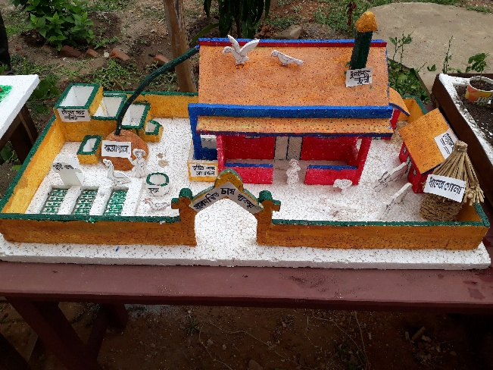
The programme started with a rally from Pabra Pahari Junior High School, facilitated by the teachers and staffs of DRCSC with a motive to make the village people concern about environment related issues. Students were carrying banner, placards having meaningful slogans related to environment. Leaflets were also distributed to everybody passing the road or gathered to see the rally.
Models displayed at the programme
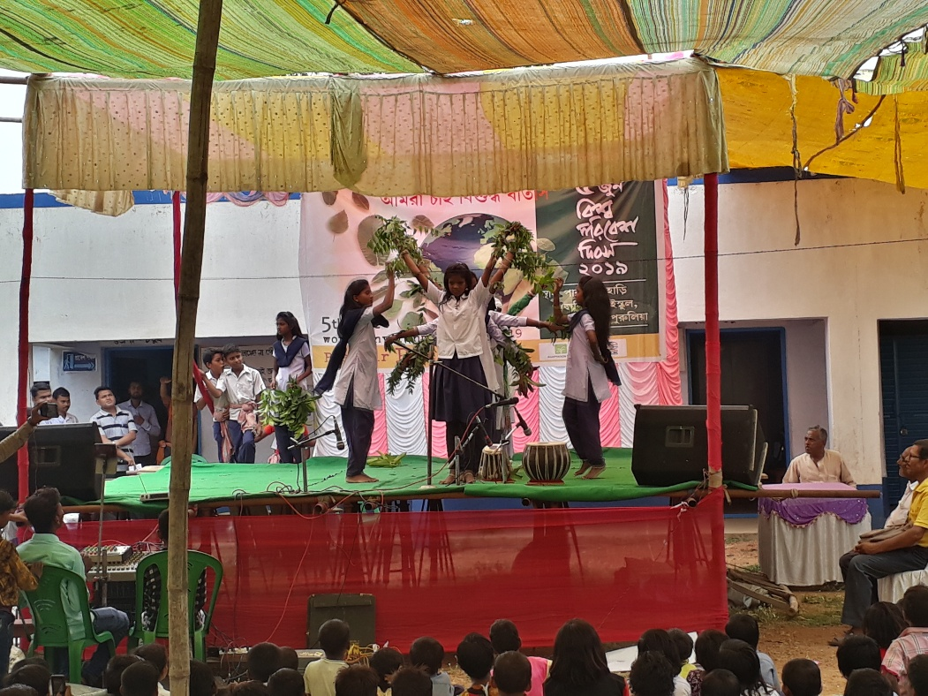
After completion of the rally the programme was inaugurated by welcoming the honourable guests and plantation of a tree. Manmath Mahata (Panchayat Upopradhan), Chittaranjan Mahata (member of Panchayat committee), Swapan Kumar Sahis (Headmaster of Pabra Pahari Primary School), Saroj Majhi (Headmaster of Pabra Pahari Junior High School), Bikas Mondal (Assistant teacher of Chitra Primary School), Anathbandhu Mondal, Ajodhyapati Mahata and Dhirendranath Mondal (the retired teachers of neighbouring schools) have enlightened the desk of honourable guests. A welcoming speech highlighting the significance of the day was given by Jharna Sinha, the District Coordinator of DRCSC, Purulia. Students of neighbouring two schools have actively participated in the programme. There were music and dance performance, pantomimes, recitations, model demonstrations and paper presentations, painting and spot quiz competition. Debjani Mondal, student of a neighbouring school has very nicely demonstrated the comparison of a village and a city through her model. Fifteen students have participated in drawing competition and reflected their views on ‘Air Pollution’ on chart paper. Through pantomimes students in five groups have very intelligently highlighted the burning environmental issues. All together 285 students were present there out of which 40 students were participated in various events. Three teachers have participated in a panel discussion on ‘Pollution and its Solution’.
The prizes were distributed among all the participants through our guests at the end of the programme. This day of 5th June, 2019 seems to be a great success. There was an arrangement of lunch for the students, teachers and other organizers on behalf of DRCSC.

Bankura:
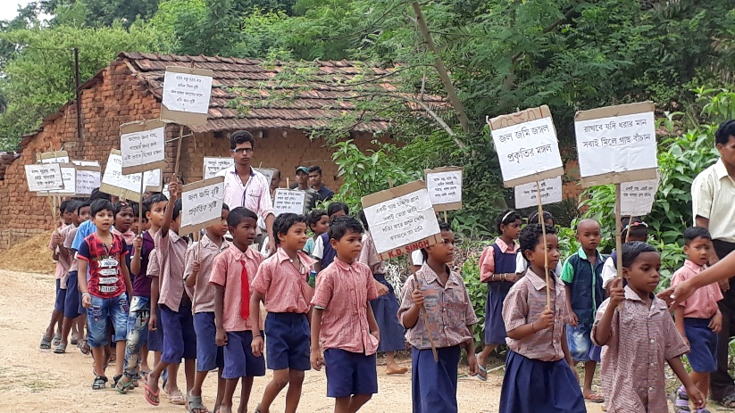
Increase in drought, health & malnutrition problems and decrease in expectancy of life signifies the problems in Bankura. Natural resources are getting extinct day by day with the decrease in forest, waterbodies, livestock etc. So the common people who have the potential to bring back a pollution free environment should take active part. With this background DRCSC Bankura Project Office, celebrated World Environment Day where 100 students, 70 SHG members were present at Laxmi Murmu Smriti Vidyalaya, Chanchanpur, Bankura.
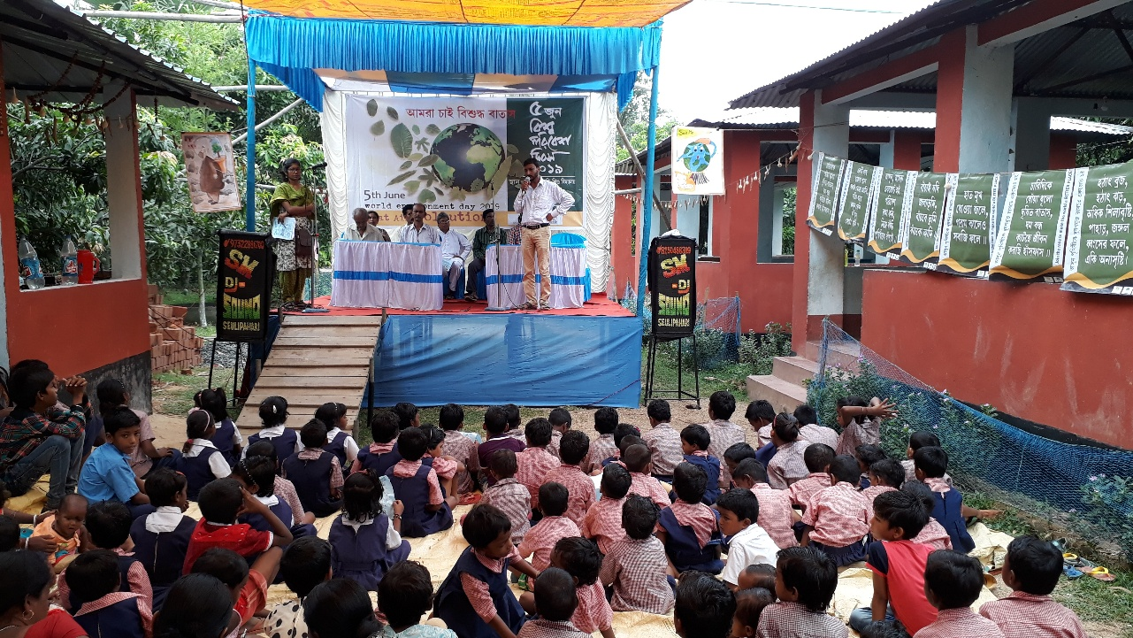
The programme started with a rally. After completion of the rally the programme started with the valuable speech by Sri Ramlal Mandi (President), Smt. Reba Murmu (Founder of Laxmi Murmu Smriti Vidyalaya), Sri Goutam Mondal and Sri Pradip Mondal (Both are the assistant teacher of Laxmi Murmu Smriti Vidyalaya), Sri Srimanta Soren and Sri Pashupati Murmu (Both are the member of Jhunjka Watershed Committee), Sri Tarapada Murmu and Smt. Arati Murmu (Both are the member of Ghoshergram Watershed Committee). Sri Asit Kumar Mondal from DRCSC signified the importance of celebration of 5th June. There was an environment related drama, tribal songs and an open quiz contest, facilitated by Ms. Debjani Roy. Sri Mithun Mondal concluded the programme with a thanks giving speech. At the end of the programme, food packets were distributed among the participants.
Inaugural speech by Sri Asit Kumar Mondal
Conclusion:

DRCSC’s endeavour towards a pollution free and clean environment will continue for creating a better place for sustainable living. The Moto for demanding ‘Pure Air’ will definitely bring encourage to the common people for saving their mother Earth.

